Editor: Erin Balke Price: jollars, jean dollars
eeb@andrew.cmu.edu Volume 19, Issue 7 – 28 Mar. 2016
_______________________________________________________________________________________________________________________________
NOTES FROM THE JEAT ............. SPRING STYLE TIPS FROM MADDY VARNER Continued
By: mvarner

2) ECONOMIC RAIN SOLUTIONS
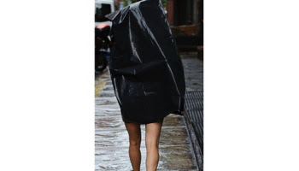 even though the sleet and snow has gone, doesn't mean there won't still be terrible weather! a garbage bag makes a chic but Cheap solution for those unexpected rainy days. a sleek black look is always in style, and you'll stay dry as well!!!!!

3) RETROREFLECTIVE BALL SUIT
there is no better way to celebrate the sunlight than an EXTREMELY REFLECTIVE fashion element!!! retroreflective ball suits are a great way to remind people that the sun is shinin' by blinding them on sight. hot!!!!!!!!!!

NOTES FROM THE JEAT ............. SPRING STYLE TIPS FROM MADDY VARNER
By: mvarner
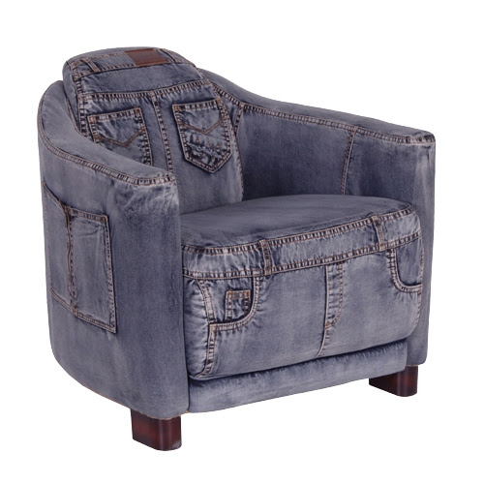
spring has SPRUNG and it's time emerge from your blanket nest and into the BEAUTIFUL sunlight. but you can't just wear your 27 snuggies at once, you gotta leave your past behind you as you embrace your ENHANCED new outdoor lifestyle!!!!!!!

1) HAMSTER POCKET
who doesn't love things that are small and fuzzy??? a HAMSTER is a beuatiful accessory that will win you friends and fans as they fawn over your fluffy pal. it might even leave you a lil gift in your pocket ;) ;) ;)

