Editor: Erin Balke Price: 2 whole things

eeb@andrew.cmu.edu Volume 19, Issue 1 − 14 Sept. 2015

_______________________________________________________________________________________________________________________________

What is Pravda?

By: eeb

Pravda? is our newsletter! It is filled with submissions from you, yes you, and other members of the KGB. What counts as a good Pravda submission? Anything that can be printed in black and white (I’m not made of print quota) would go into a Pravda. A short story, a poem, a drawing, cute animal pictures, the hottest dance craze drawn with stick figures, bad jokes, good jokes, and anything in between.

How often does Pravda come out? Well, that depends on you. The more submissions I get, the less material I have to think of on my own, and the quicker I can make a Pravda.

Send Pravda submissions to [corsec@cmukgb.org](mailto:corsec@cmukgb.org) or eeb@andrew.cmu.edu

How the KGB works

By: eeb

This is a KGB meeting (assuming it is Monday between 4:30 and 5:30). Normally, we meet in Margaret Morrison A14. Any exceptions will be posted on our Facebook page and emailed out to the general body. Confused about what is going on? Most people are. Attached on the back is a handy dandy flow chart from 2011 that explains how a normal meeting works.

Some important things to note about our meetings:

* Raise your hand to talk, that way everybody can hear your joke and appreciate it.
* The auctions are in real American dollars
* Ask old people (anybody who’s been around for a couple years) to explain jokes/references/what’s going on.
* Sometimes jokes are so old nobody knows why they are funny anymore, they just are.
* We take having fun very seriously. If you have an idea for fun, feel free to share it.

Exec is here to make sure the organization functions. We want to make sure everybody is having the best possible time. Feel free to reach out to us at any time via email ([exec@cmukgb.org](mailto:exec@cmukgb.org)) or at our exec meetings (Wednesday 7:30 in CUC “318G”)

The Officers

By: eeb

**President: Mike**

Mike runs our meetings! They may

or may not also be involved with the

creation of “The Molecule”TM

**First Vice President: Sky(e)**

Skye’s job is to know EVERYBODY

in the KGB and make sure they stick

around. She also does other fun things;

such as shoot other people with nerf

guns.

**Second Vice President: Dillon**

Dillon runs all of the events. All

of them. Every single one. It’s his

job to make sure you all know when

the events are happening.

**Corresponding Secretary: Erin**

That’s me! I make the Pravda?,

send all sorts of official emails,

and keep things organized. Ask

me about catspericy theories.

**Recording Secretary: Zora**

If it happened at a meeting, Zora

wrote it down….probably. They

take the notes of all of the important,

and unimportant, business that

happens here and posts the notes to

our wiki!

**Treasurer: Joe**

Joe handles the monies. We have

a bunch of expenses with all of the

Oreos we buy, and it’s his job to

make sure we don’t accidentally

spend all of our money twice.

**Sargent at Arms: Murphy**

Murphy protects the President,

and carries things, and is super

duper helpful. He picks up the

slack when the rest of us drop it

on the floor.

A Bad Joke

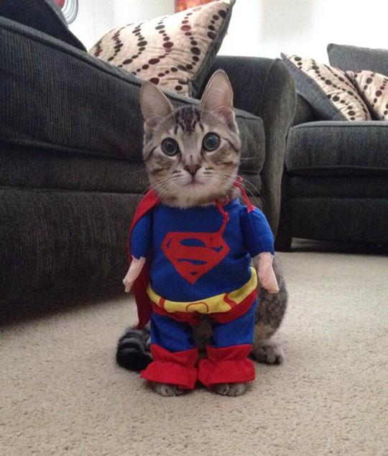



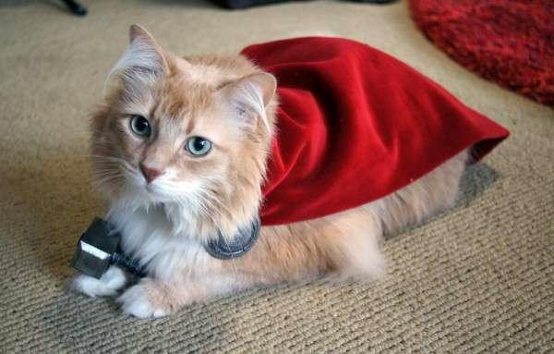



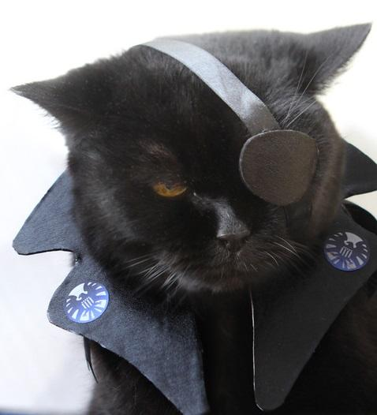

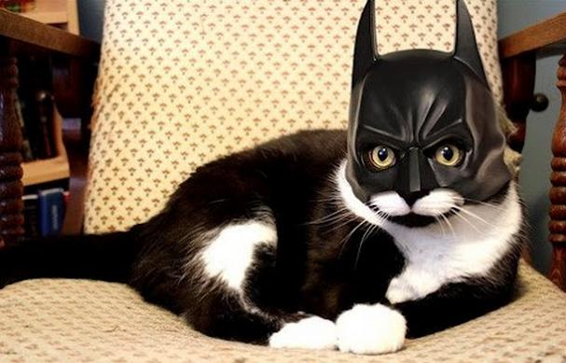

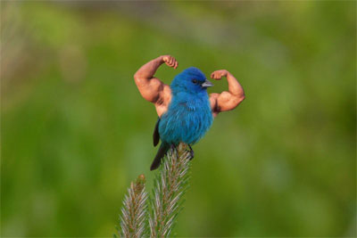

Meeting Flow Chart

By: kharring

