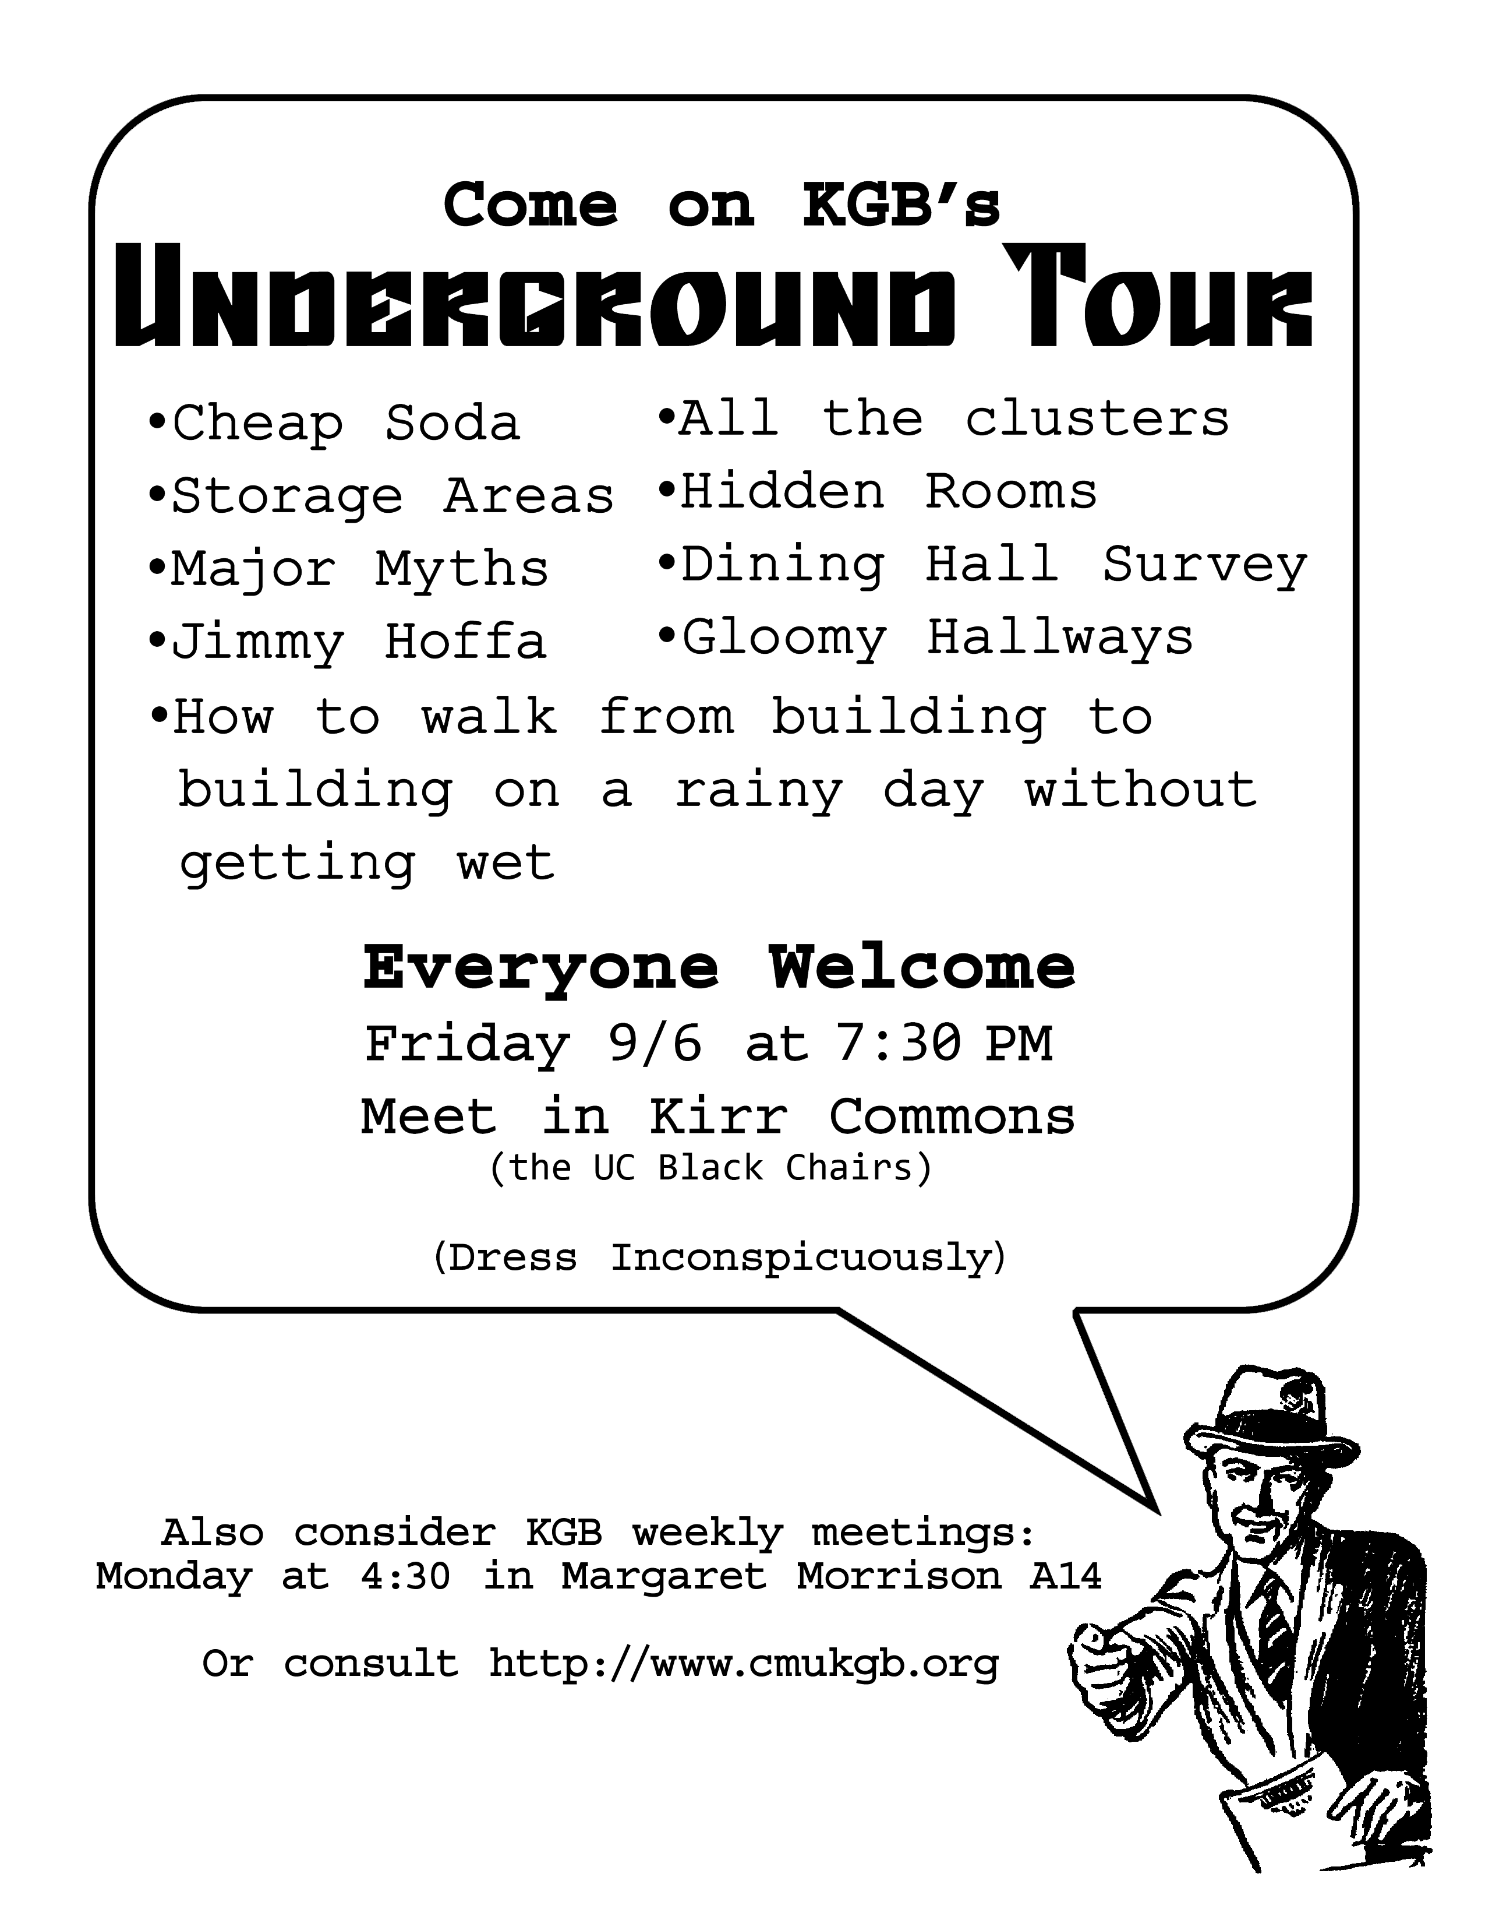

Flip for a message from our sponsors ->

It is a scientific fact that people who go on The Underground Tour are 30% harder to detect by grizzly bear. Which, considering next week’s forecast, will definitely be a plus.

Have you ever felt like something was just missing? What about your nose? Have you ever actually seen your nose? How would you know if it was not replaced by an illusionary one?

You have heard the great howling in your dreams. Come to the Tour of the Underground to find the next steps, or come anyways and act as if you have. Because, you know, all the **cool** kids have heard the great howling and making others think you are cool is the important bit anyways.